Lab 16: Server-side request forgery (SSRF)
Objective:
- This lab centers around Server-Side Request Forgery (SSRF) attacks, where an attacker abuses the functionality of a server, causing it to access or manipulate information in unintended ways. Participants will engage with a simulated environment where an application is vulnerable to SSRF.
In this lab, students need to:
- Answer the following questions:
  - What is Server-Side Request Forgery (SSRF), and how does it differ from other types of web application vulnerabilities?
  - Describe a methodology for exploiting an SSRF vulnerability in a web application. What are the key steps and techniques involved in crafting and sending malicious requests to exploit SSRF vulnerabilities?
- Perform challenge:
  - Blind SSRF with out-of-band detection
- Explain and capture all steps (full windows screen capture).
Group Members:
- Phạm Hoàng Hải Nguyên (SE180511)
- Nguyễn Trúc Quỳnh (SE180280)
- Giã Thị Nhã Trân (SE180405)

Submit a report addressing all the questions mentioned above in either PDF or Markdown format. Additionally, include a video demonstrating the detailed process of your work to ensure the authenticity of your lab exercise.
The report file name must be Class_YourStudentID _YourName_Lab16

Blind SSRF with out-of-band detection
Opens the lab "Blind SSRF with out-of-band detection" on PortSwigger Web Security Academy inside a Kali Linux VM. Burp Suite Professional is running alongside the browser, and the lab page explains the objective: the application fetches an external URL specified in the Referer header when a product page loads. The lab status shows "Not solved", indicating the student is at the starting point before any exploitation attempt.
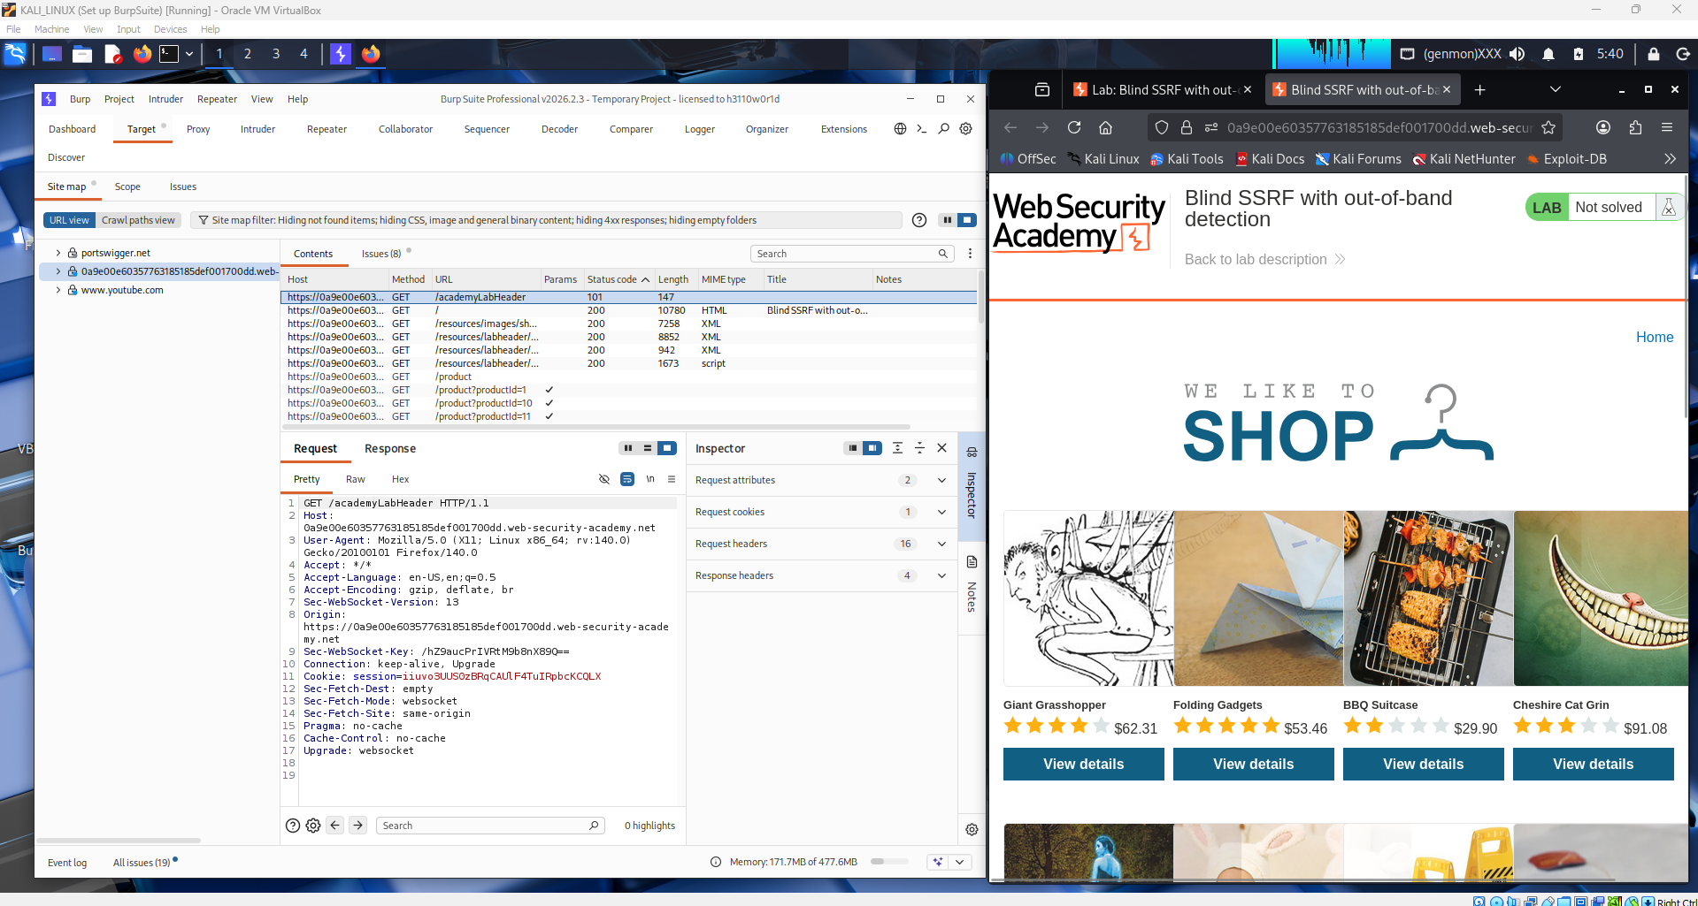

Navigates to one of the product pages on the target shopping website to trigger an HTTP request that includes the Referer header. Burp Suite's Proxy is intercepting live traffic, and the Site Map is beginning to populate with requests made to the lab domain. This step is necessary because the vulnerable Referer header only appears when a product detail page is visited.
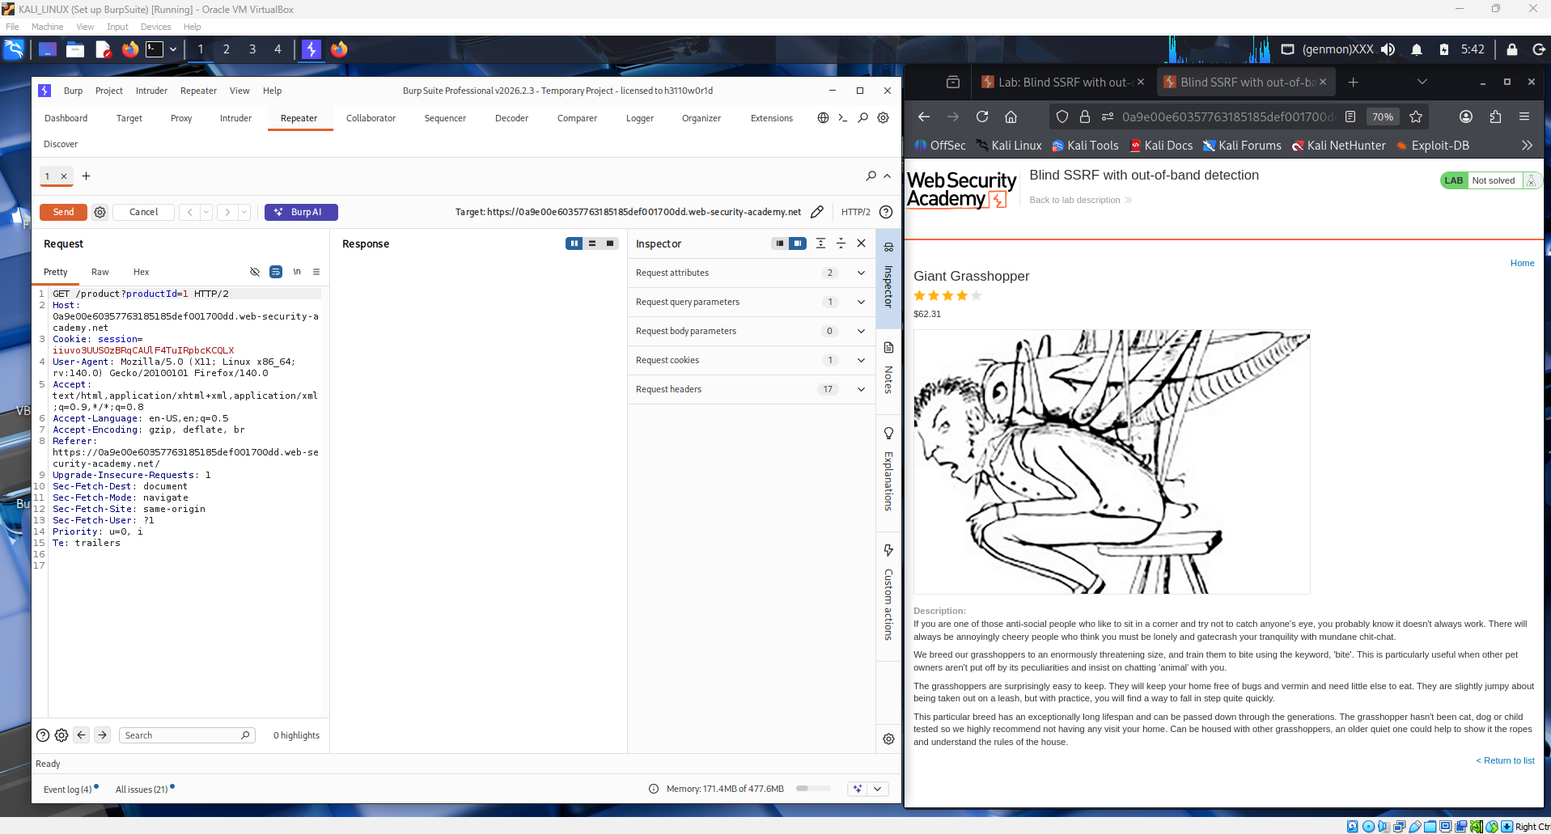

Locates the intercepted GET request to /product?productId=1 in Burp Suite's HTTP history. The full raw request is visible in the Inspector panel, and the student can clearly see the Referer header pointing to the lab domain. This is the key injection point — the server-side application reads this header and makes a backend HTTP request to whatever URL is placed there.
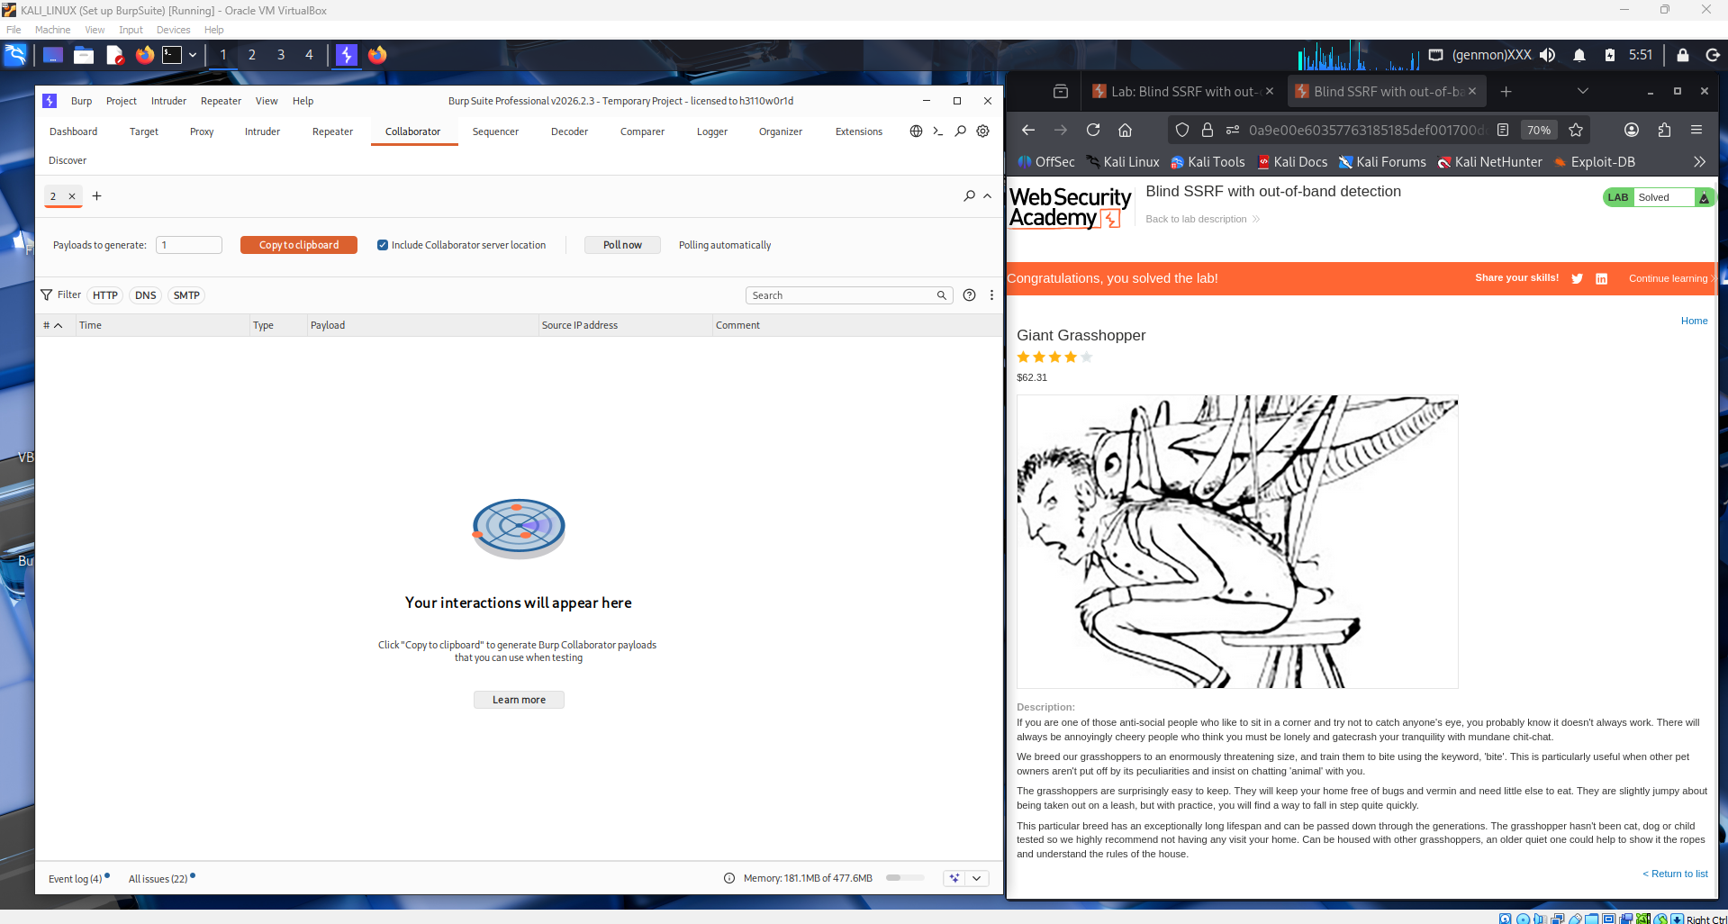
Right-clicks the captured request and sends it to Burp Repeater so it can be manually modified and resent without going through the browser. This allows precise control over the request headers, specifically the Referer value, without triggering normal browser behavior.
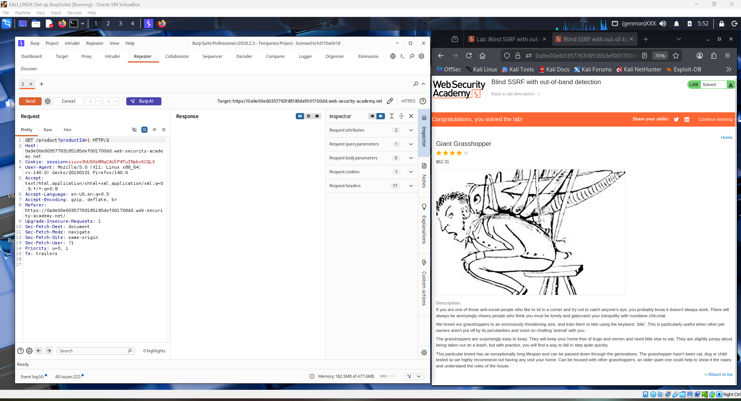
Inside Burp Repeater, the student modifies the Referer header value, replacing the original URL with the Burp Collaborator payload URL (a unique subdomain generated by Burp that records any incoming DNS or HTTP interactions). This is the core of the blind SSRF exploit — the server will silently reach out to that external URL.
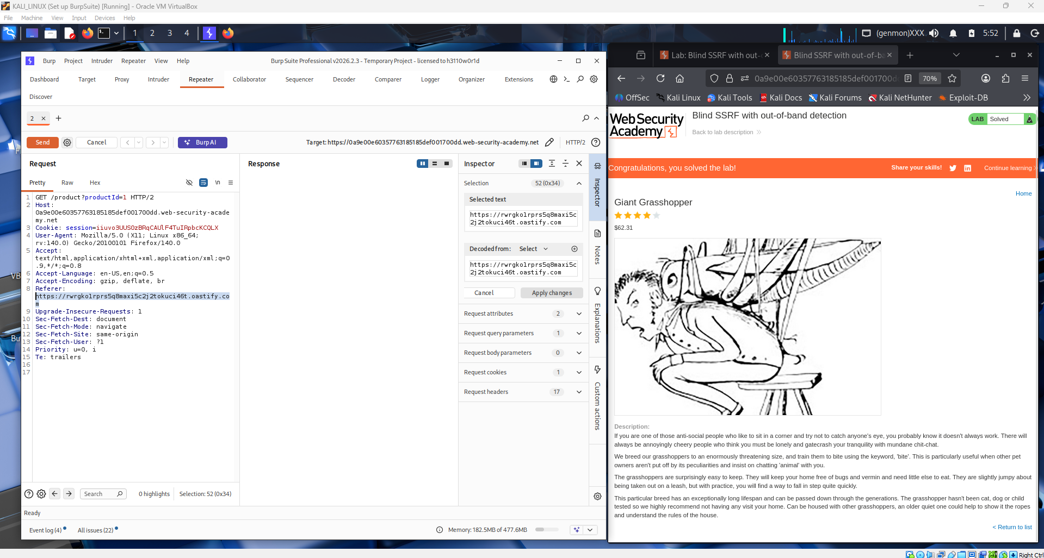

Sends the modified request by clicking the Send button in Repeater. The server receives the request and, as expected from the lab description, makes a backend HTTP call to the Collaborator URL embedded in the Referer header. The response from the server itself may look normal, but the real evidence is captured out-of-band.
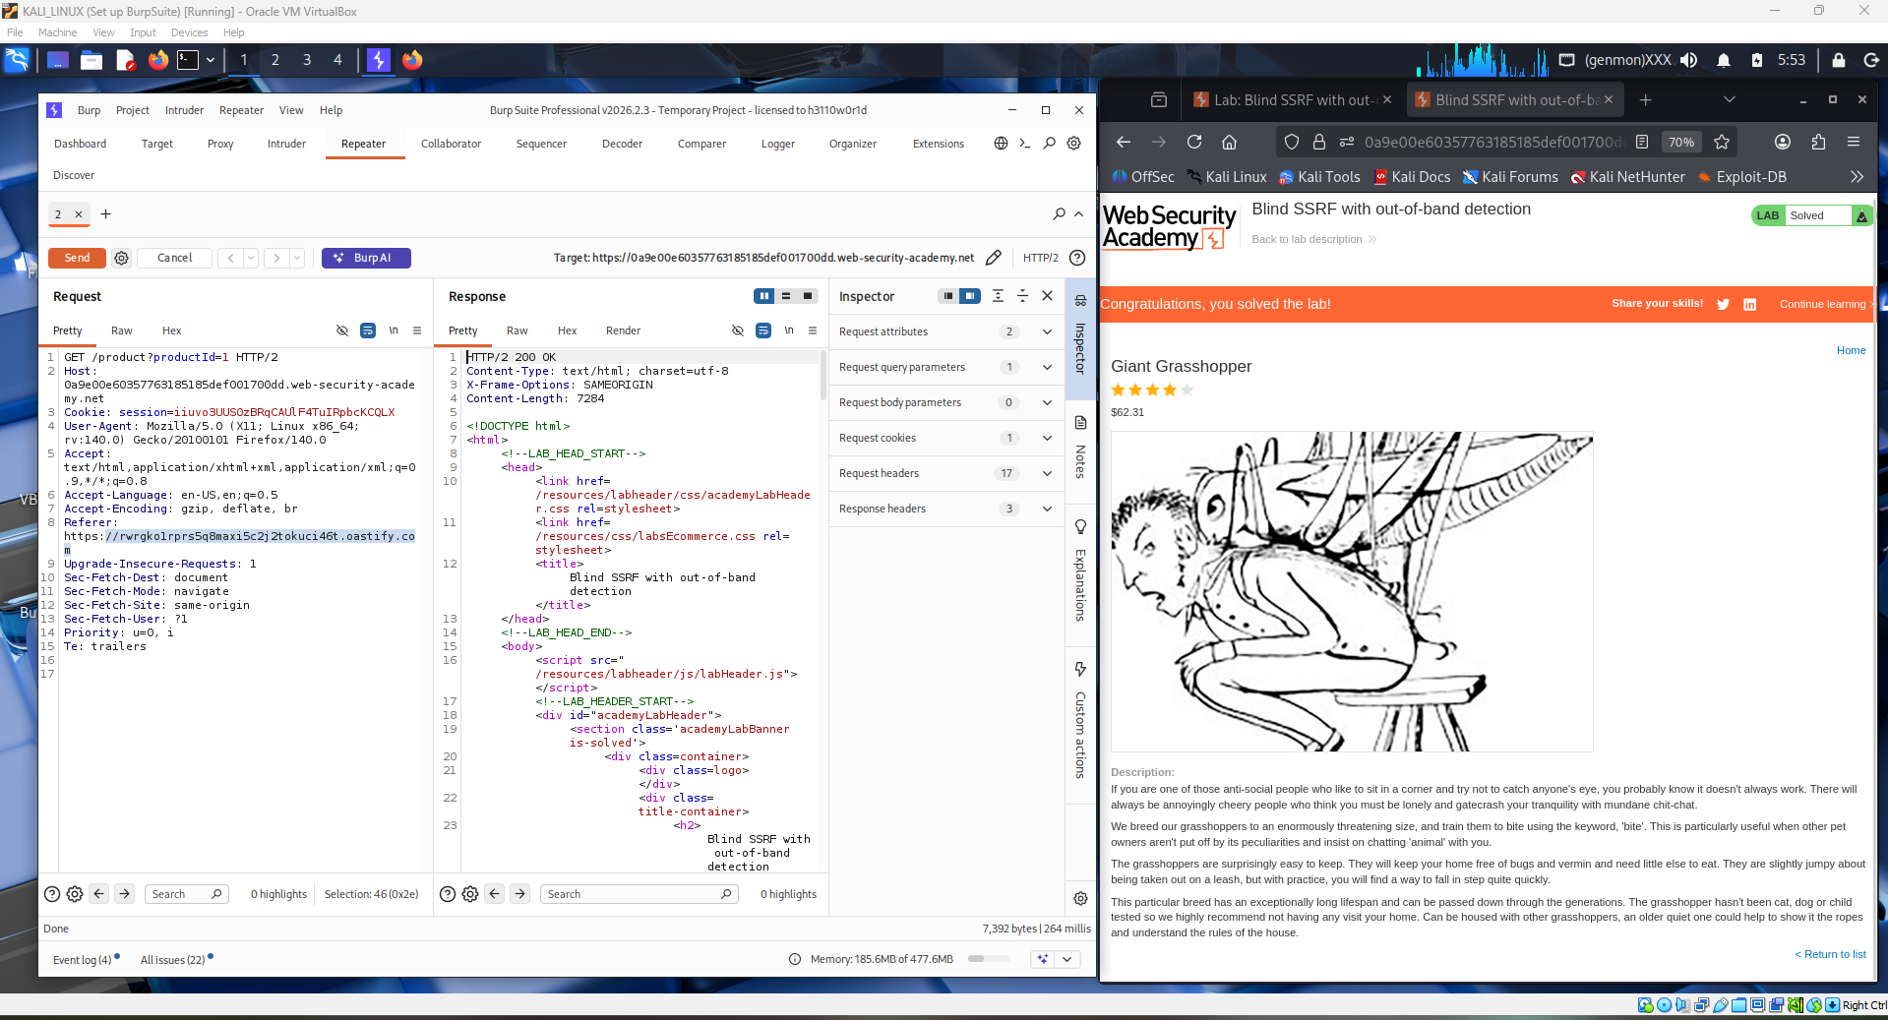

Opens the Burp Collaborator client and clicks "Poll now" to check for any incoming interactions. The panel shows a DNS lookup and/or HTTP request originating from the lab server's IP address hitting the Collaborator subdomain, confirming that the server-side request was successfully triggered by the injected Referer header.
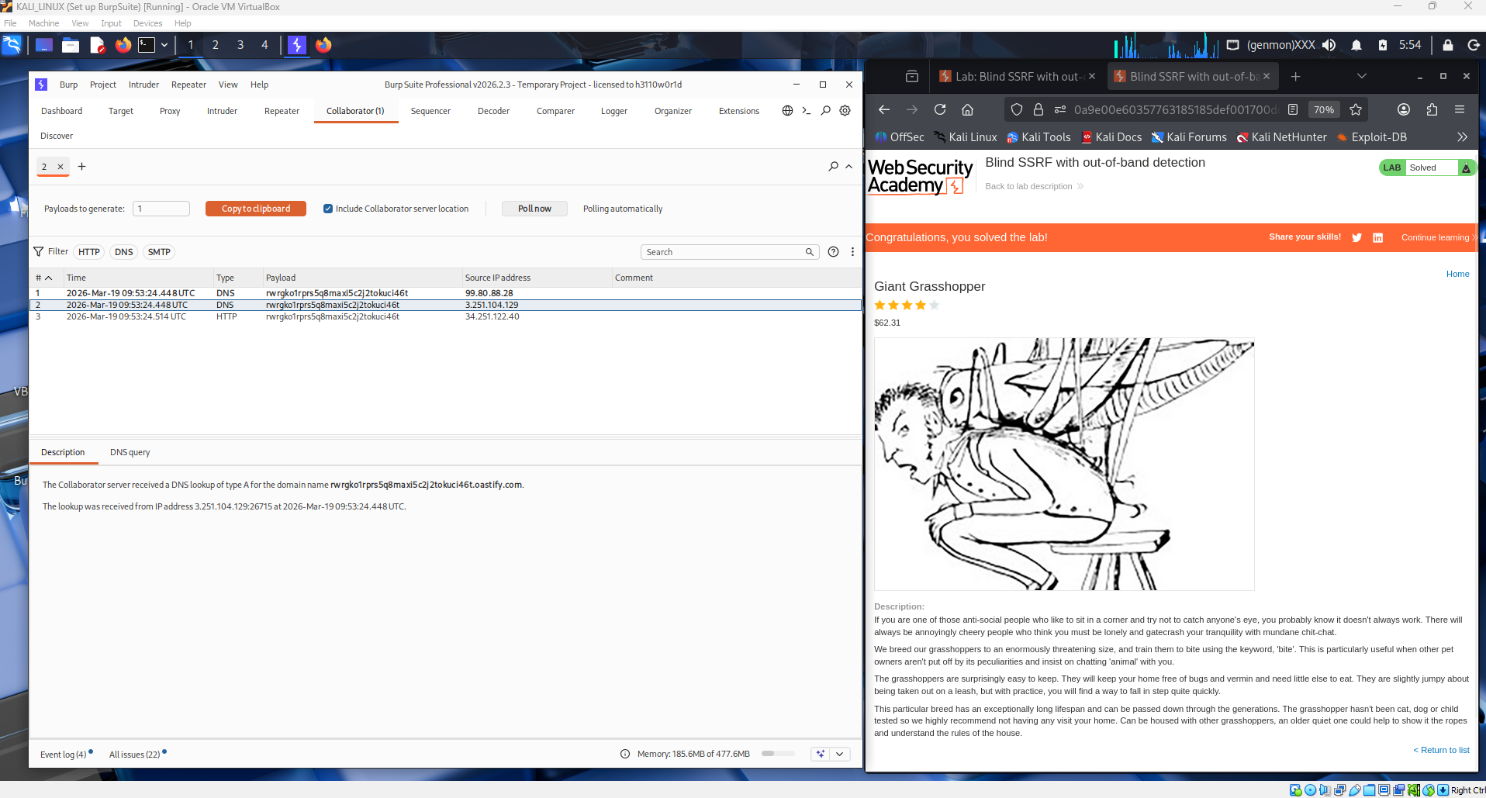
The lab banner updates to show "Solved", confirming the successful exploitation of the blind SSRF vulnerability. The student has demonstrated that the application makes out-of-band HTTP requests based on the Referer header without returning any direct feedback in the HTTP response, which is the defining characteristic of blind SSRF.
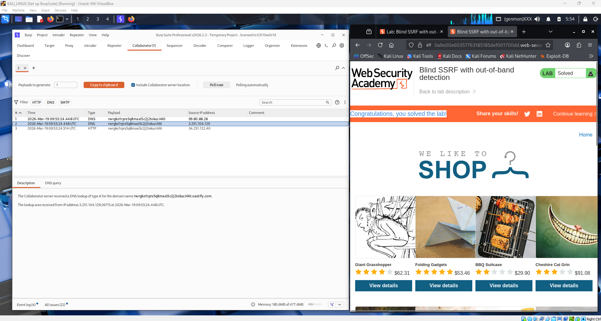
Q1: What is Server-Side Request Forgery (SSRF), and how does it differ from other types of web application vulnerabilities?
Server-Side Request Forgery is a vulnerability where an attacker can manipulate a server-side application into making HTTP requests to an arbitrary destination chosen by the attacker, rather than the intended one. The server acts as a proxy on the attacker's behalf, which means requests originate from a trusted internal machine rather than from the attacker directly.
SSRF differs from other web vulnerabilities in several key ways. Unlike XSS or CSRF, which target the client-side or abuse the victim's browser session, SSRF operates entirely on the server side — the victim is the server itself. Unlike SQL injection or command injection, which corrupt data processing logic, SSRF abuses the application's network-level functionality. It is particularly dangerous because it can bypass firewalls and access controls that block external requests, allowing attackers to reach internal services, cloud metadata endpoints (such as http://169.254.169.254), or other backend systems that are never exposed to the public internet. Blind SSRF, as demonstrated in this lab, is an even stealthier variant where the server's response gives no direct indication that a request was made — the interaction is only observable through out-of-band channels like DNS lookups.

Q2: Describe a methodology for exploiting an SSRF vulnerability in a web application.
Step 1 — Reconnaissance and surface mapping. The first step is to identify all locations in the application where a URL or hostname is submitted and then fetched by the server. Common injection points include URL parameters, Referer headers, Host headers, API fields that accept webhook URLs, and document/file import features.
Step 2 — Confirm basic SSRF. Inject a URL pointing to a controlled external server (such as Burp Collaborator or interactsh) into the identified parameter. If an HTTP or DNS callback is received, SSRF is confirmed. For blind variants, this out-of-band interaction is the only confirmation available.
Step 3 — Probe internal network. Once SSRF is confirmed, attempt to reach internal resources. Common targets include http://127.0.0.1/, http://localhost/admin, and cloud metadata endpoints like http://169.254.169.254/latest/meta-data/. Scan common internal ports by iterating through IP ranges or port numbers to map the internal network.
Step 4 — Bypass filters. Applications often implement blocklists or allowlists. Common bypasses include using alternative IP representations (e.g., http://2130706433/ for 127.0.0.1), using DNS rebinding, using redirects from an allowlisted domain to a blocked one, or abusing URL parsing inconsistencies.
Step 5 — Escalate impact. Once internal access is established, attempt to retrieve sensitive data such as cloud credentials from metadata services, access unauthenticated admin panels, or pivot to other services on the internal network.
Step 6 — Document with out-of-band tools. For blind SSRF, always use Burp Collaborator or similar tools to record DNS and HTTP interactions, as the server response alone will not confirm success.

Conclusion
This lab demonstrated a blind SSRF vulnerability where the target application silently makes backend HTTP requests based on the value of the Referer header. Unlike regular SSRF, the blind variant produces no visible output in the HTTP response, making it undetectable without out-of-band observation techniques. By injecting a Burp Collaborator URL into the Referer header and observing the resulting DNS and HTTP callbacks, the student successfully confirmed that the server was making unauthorized outbound requests on behalf of the attacker. This exercise highlights how even seemingly harmless HTTP headers can become critical attack vectors, and reinforces the importance of validating and sanitizing all server-side URL inputs — not just user-visible parameters. In a real-world scenario, such a vulnerability could be chained to access internal metadata services, enumerate backend infrastructure, or exfiltrate sensitive credentials from cloud environments.

